CL 50
ELECTRONIC ICU BED, 5 MOTORS, COLUMN MOTORS
- Electrically operated backrest, height, and legrest adjustment
- Electrically operated Trendelenburg, Reverse Trendelenburg, Fowler, and vascular position
- Lateral tilt functionality for enhanced patient positioning
- Foot end nurse control unit
- Control panels embedded on side rails: 2 for patients, 2 for nursing staff
- Footrest adjustment by ratchet
- Auto-CPR
- Auto Regression system on backrest
- Auto contour
- Hygienic design (PP), lockable, and tuck-away side rails
- Easy removable ABS mattress platform
- X-ray cassette holder
- Removable headboard and footboard
- Electrostatic epoxy-painted metal frame
- Height-adjustable stainless steel IV pole
- Plastic protective crash bumpers on four corners
- Central Lockable Castors, 150 mm
- Angle indicator for backrest
- Angle indicator for Trendelenburg and Reverse Trendelenburg positions
- Cardiac chair position with single button
- Shock position with single button
- Semi-Fowler position with single button
- Bed exit position with single button
- Examination position with single button
- Electronic CPR with one-touch button
- Foot switch control for additional convenience
- Activation key at remote control to prevent undesired positions
- Dual-sided manual CPR levers at backrest
- Urine bag holder
- Rechargeable battery backup
- Bed size extension (optional)
- X-ray cassette holder at backrest
- IPX6 standard electronic system
 | TECHNICAL DETAILS
 | Overall Length | : 220 cm
 | Overall Width | : 100 cm
 | Mattress Surface | : 85 x 200 cm
 | Height | : 50-88 cm
 | Trendelenburg | : 0°-15°
 | Reverse Trendelenburg | : 0°-15°
 | Lateral Tilt (Right) | : 0°-17°
 | Lateral Tilt (Left) | : 0°-17°
 | Backrest Angle | : 0°-70°
 | Legrest Angle | : 0°-40°
 | Castor Diameter | : 15 cm
 | Under bed Clearance | : 15 cm
 | Safe Working Load | : 250 kg

 | ELECTRICAL DATA
 | Power In | : 1.5A max. At 230V AC 50-60 Hz
 | Electrical Shock Protection | : Class I, Type B
 | Liquid Ingress Protection | : IPX6
 | Batteries | : 2x 12V Series Connected, sealed, rechargeable, Lead / Acid gel, 1.2 amp hrs.

OPTIONAL ACCESSORIES
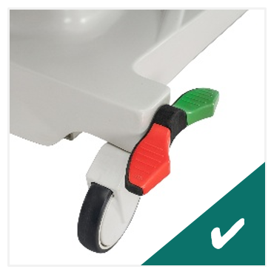
Central Brake Castors, 150 mm
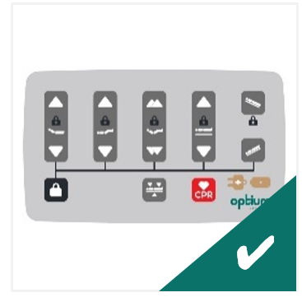
Foot-end Nurse Control Panel
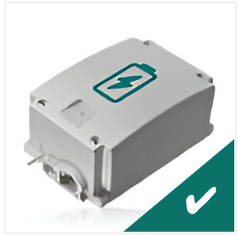
Rechargeable Battery Backup
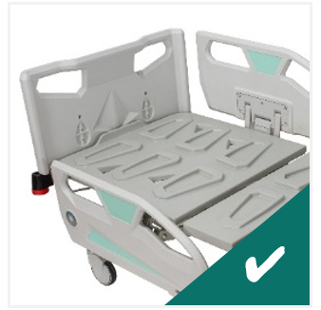
X-Ray Cassette Holder at Backrest
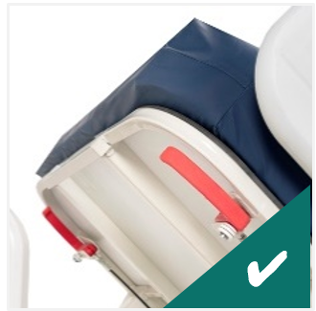
Dual Sided Manual CPR at Backrest
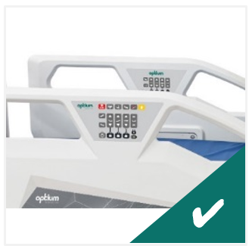
Control Panels Embedded on Side Rails
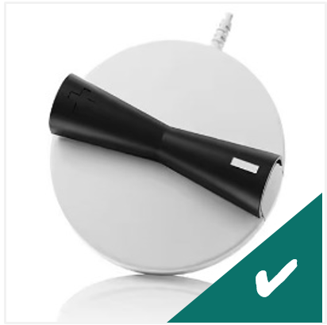
Foot Switch
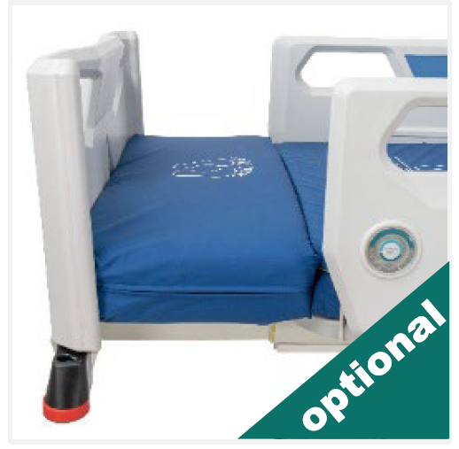
Bed Extension
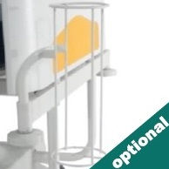
Oxygen Cylinder Holder
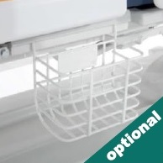
Urine Bag Basket
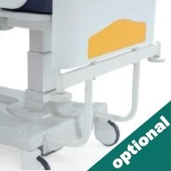
Stationary Headboard
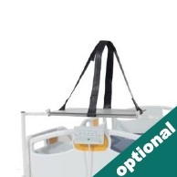
Defibrillator Shelf
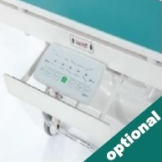
Nurse Panel Shelf
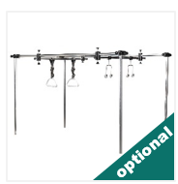
Orthopedic Traction System
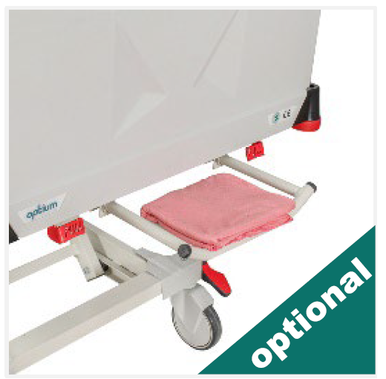
Linen Holder
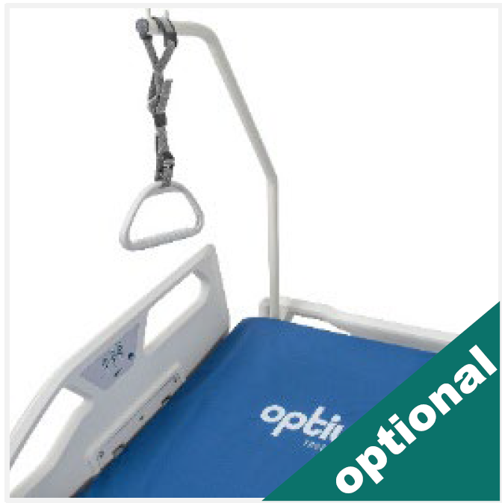
Lifting Pole
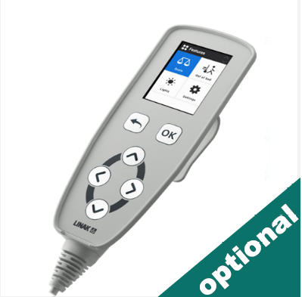
Weight Scale System
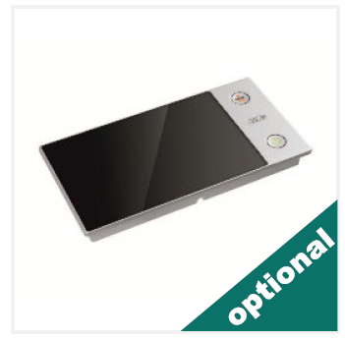
Touch Screen foot-end bed
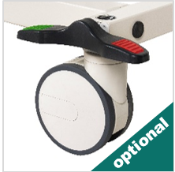
Double Wheels
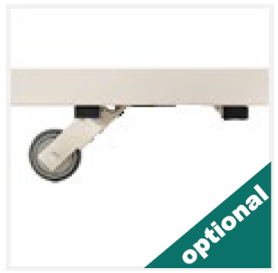
5th Castor
COLOR CHART
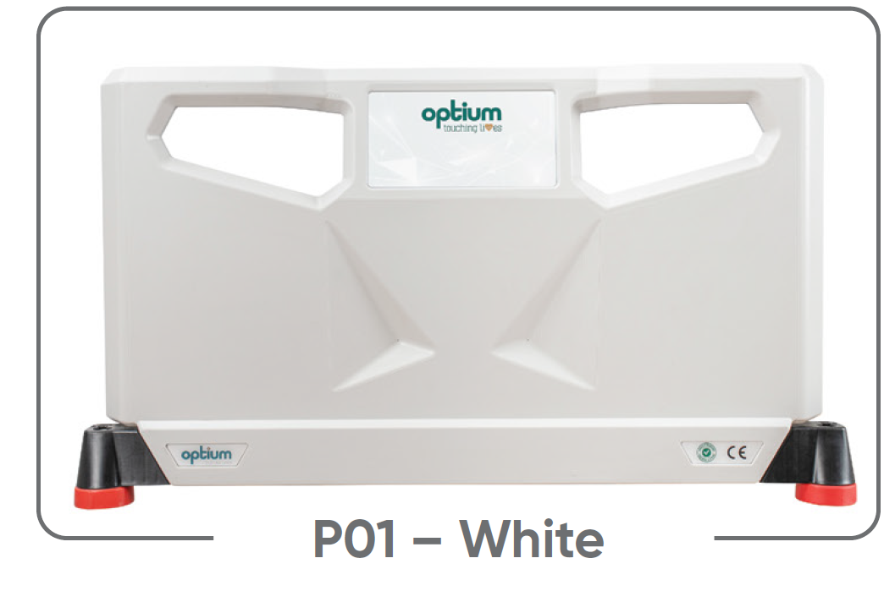
P01 – White
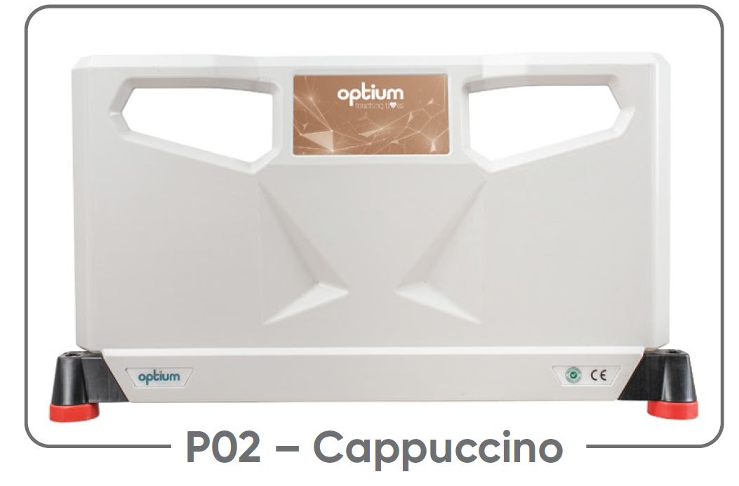
P02 – Cappuccino
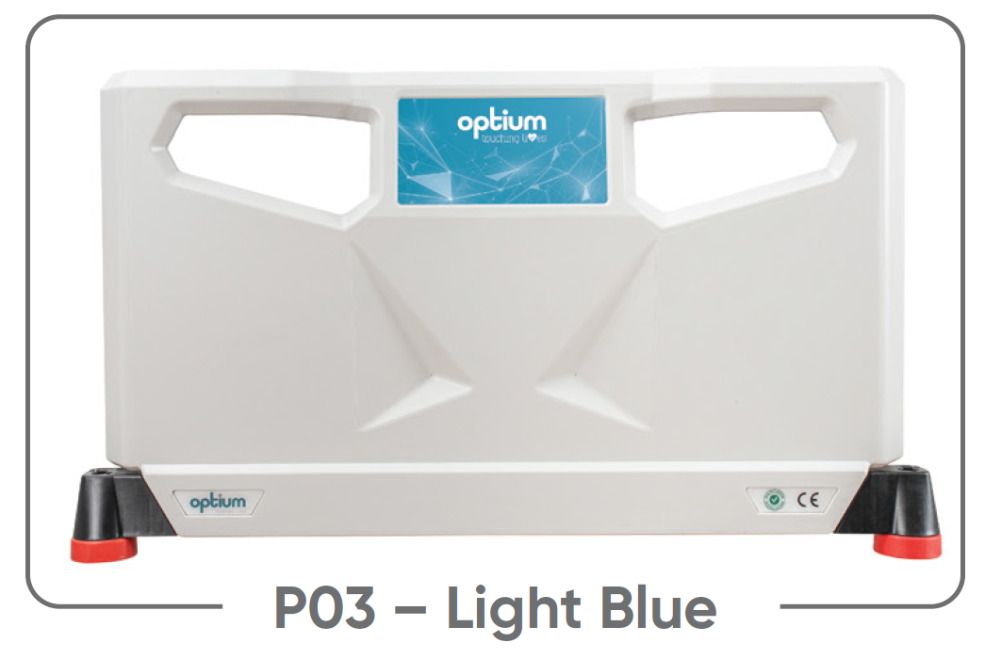
P03 – Light Blue
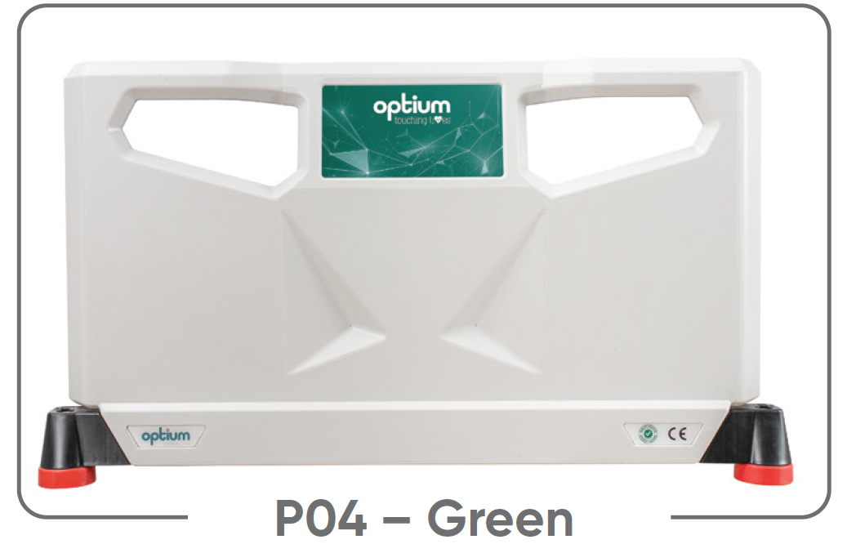
P04 – Green
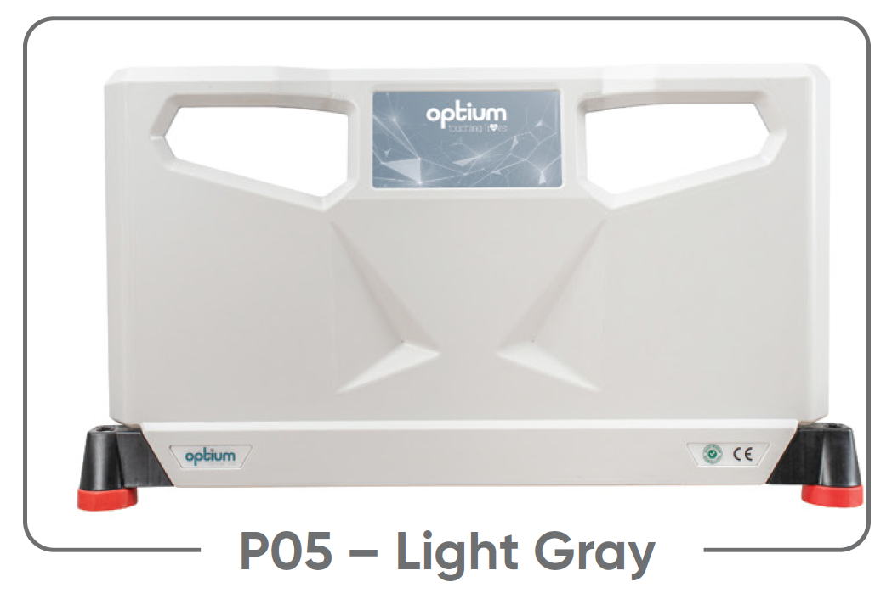
P05 – Light Gray
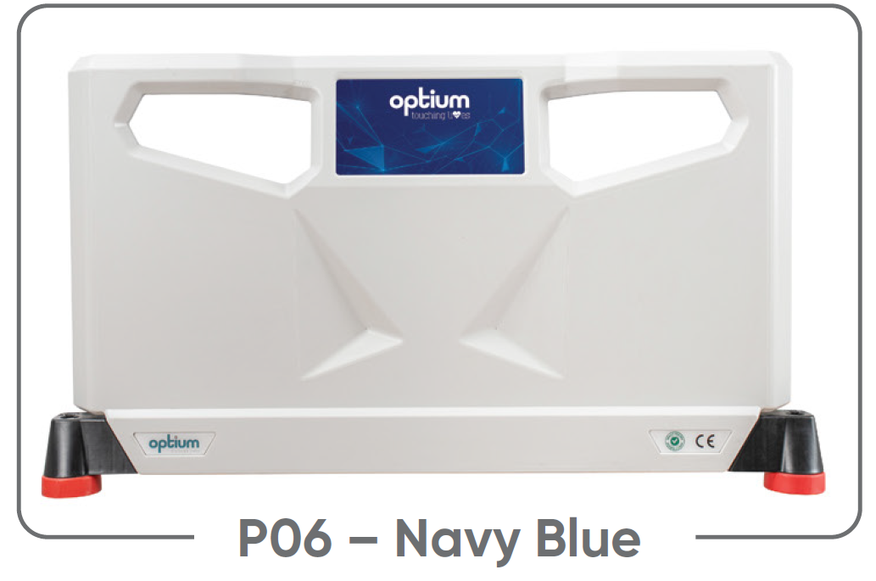
P06 – Navy Blue
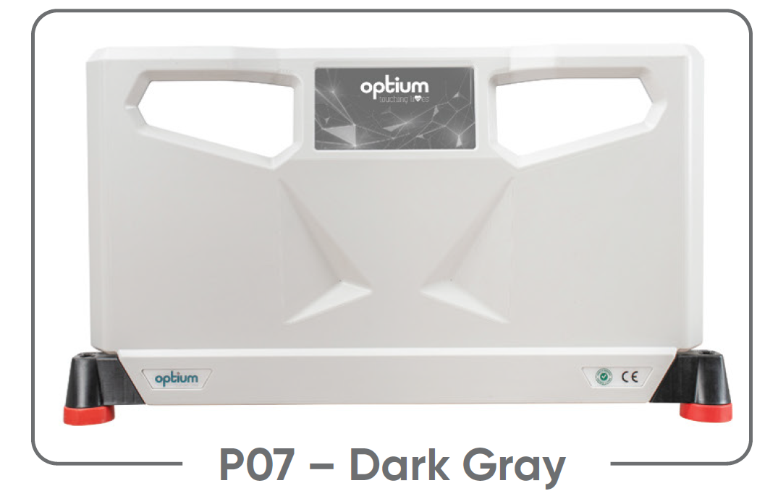
P07 – Dark Gray
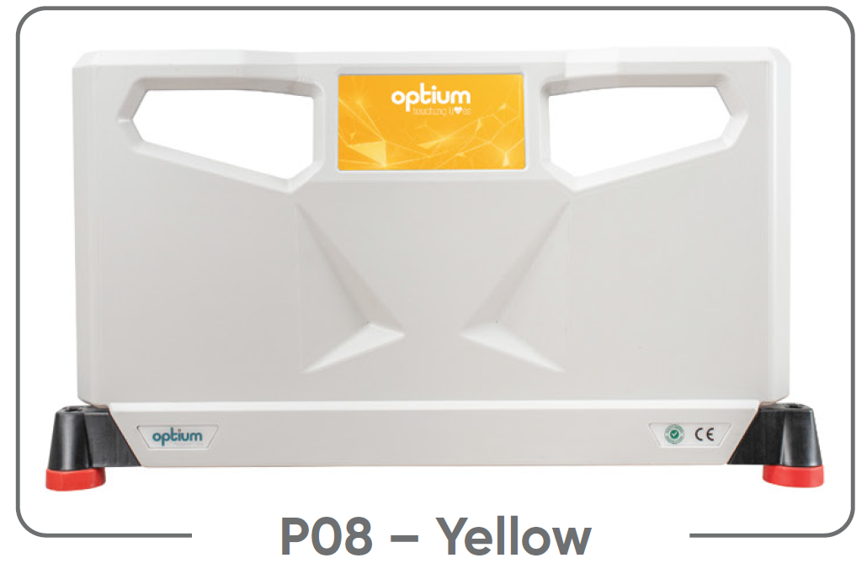
P08 – Yellow
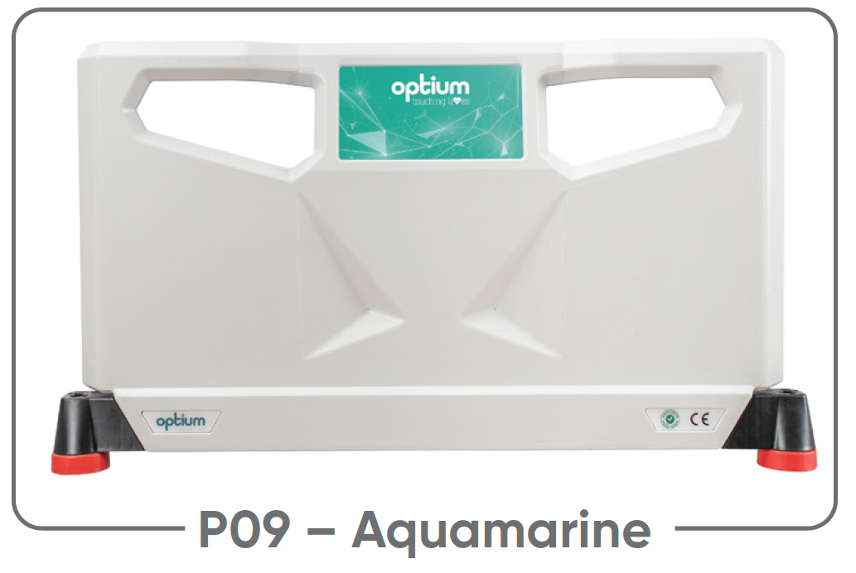
P09 – Aquamarine
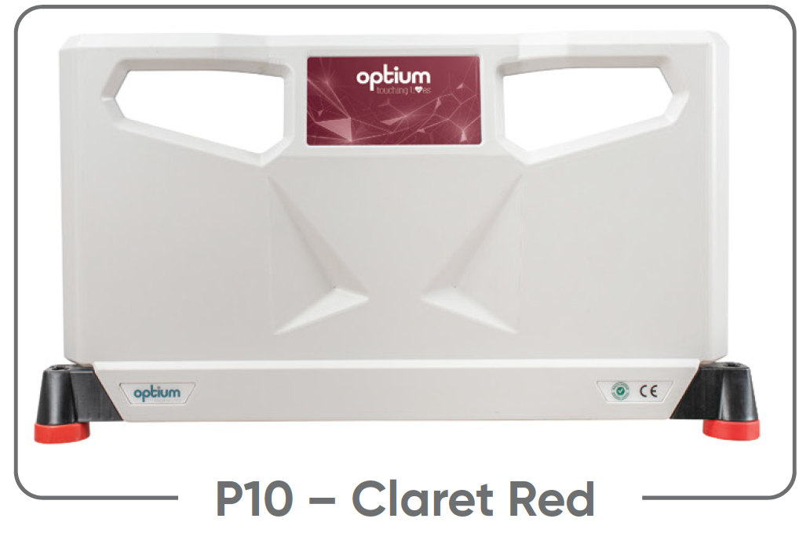
P10 – Claret Red

